**Annexure-IX (a)**

**Web Development**

**suman tech**

**A summer training report**

Submitted in partial fulfilment of the requirements for the award of degree of

**Diploma in Computer Science and Engineering**

**Submitted to**

**LOVELY PROFESSIONAL UNIVERSITY**

**PHAGWARA, PUNJAB**



**From 06/09/2025 to 07/08/2025**

**SUBMITTED BY**

**Name of student: Shalu kumari Submitted to:**

**Registration Number:12316396**

# Signature of the student: Director

**Annexure-IX (b): Student Declaration**



**Lovely Professional University, Jalandhar, Punjab**

# CERTIFICATE

I hereby certify that the work which is being presented in the industrial summer training entitled **Web Development** in partial fulfilment of the requirement for the award of degree of **Bachelor of Technology** and submitted in Department of Polytechnic, Lovely Professional University, Punjab is an authentic record of my own work carried out during period of summer training under the supervision of **Mr. Shivendra Prakash suman**, Department of **Industrial Training, suman tech**,

The matter presented in this summer training has not been submitted by me anywhere for the

award of any other degree or to any other Institute.

## Date: Shalu kumari

This is to certify that the above statement made by the candidate is correct to best of my knowledge.

## Date: Mr. Shivendra Prakash

 Industry Supervisor

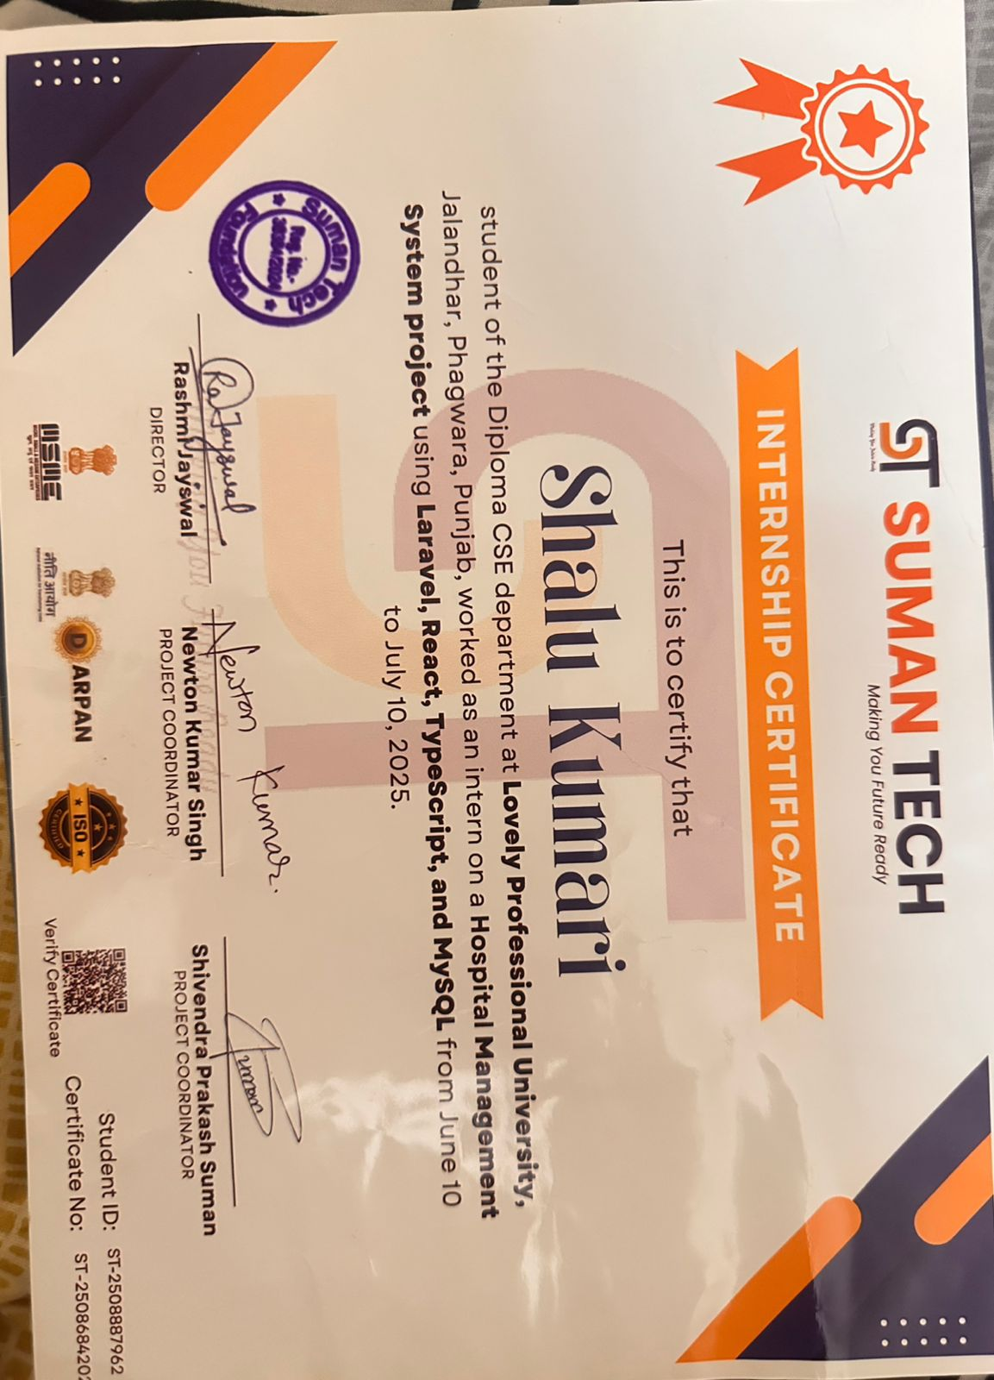

# Acknowledgement

I would like to express my sincere gratitude to everyone who supported and guided me throughout the successful completion of my project on **Hospital management system**, which was an integral part of my internship at **Suman tech Muzaffarpur, Bihar**.

First and foremost, I would like to thank Webcodeft Technology for offering me this wonderful opportunity to gain hands-on experience in the field of web development. My heartfelt thanks to the **CEO, Mrs. Rashmi Jayswal**, for leading such an inspiring organization. I am especially grateful to **Mr. Newton kumar Singh** for her constant guidance, support, and valuable insights during my internship. Her mentorship played a vital role in shaping my skills and understanding of real-world web development.

Additionally, I wish to acknowledge my academic institution and faculty members for their support and for providing me with the foundation necessary to undertake this training. Their teachings have been pivotal in shaping my understanding and approach towards this project. Lastly, I am deeply grateful to my family and friends for their unwavering support and encouragement throughout this journey. Their belief in my abilities has been a constant source of motivation.

Thank you all for your invaluable contributions and support.

# Abstract

Internship training plays a crucial role in bridging the gap between academic knowledge and real-world application, especially in the field of computer science and web development.  
As a student of **Diploma in Computer Science and Engineering** at **Lovely Professional University**, I had the opportunity to undertake a **one-month internship at Suman tech**, a growing web development firm. This experience provided valuable insights into the professional world of website creation and digital design, particularly within the home décor niche.

Suman tech, under the leadership of **Mrs. Rashmi Jayswal (CEO)**, has made significant contributions in the domain of customized web solutions. During my internship, I was guided and mentored by **Mr. Newton kumar Singh**, whose expertise and support were instrumental in my learning journey.

This report summarizes the development of a **Hospital management system** built using HTML, CSS, JavaScript, and PHP React ,Laravel, my SQL. The project involved creating functional and user-friendly web pages such as the Home Page, About Us, Contact Us, and Add to Cart features. Throughout the training, I gained hands-on experience in frontend and backend development, website structuring, form handling, and user interaction design.

Key learning outcomes of this training include:

* Understanding the workflow and environment of a professional web development company.
* Gaining practical knowledge of UI principles, responsive design, and client-side scripting.
* Strengthening problem-solving skills while working on real-time web functionalities and logic.

This internship not only enhanced my technical skills but also prepared me to face future challenges in the IT industry with confidence and creativity.

**List Of Tables**

|  |  |  |
| --- | --- | --- |
| **S. No.** | **Title** | **Page** |
| 1 | Declaration by Student | 2 |
| 2 | Training Certification from organization | 3 |
| 3 | Acknowledgement | 4 |
| 4 | Abstract | 5 |
| 5 | List of Tables | 6 |
| 6 | List of Figures/ Charts | 6 |
| 7 | List of Charts | 7 |
| 8 | List of Abbreviations | 7 |
| 9 | Chapter-1 INTRODUCTION OF THE COMPANY | 8-12 |
| 10 | Chapter-2 INTRODUCTION OF THE PROJECT UNDERTAKEN | 13-15 |
| 11 | Chapter-3 INTRODUCTION OF THE PROJECT UNDERTAKEN | 16-26 |
| 12 | Chapter 4: PROJECT IMPLEMENTATION AND WORK DONE | 27-30 |
| 13 | Chapter 5: WEBSITE LOCALLY USING WORDPRESS AND XAMPP | 31-37 |
| 14 | Chapter 6: CONCLUSION | 38-40 |
| 15 | Final Chapter- CONCLUSION AND FUTURE PRESPECTIVE | 41 |
| 16 | References | 42 |

**List of Figures**

|  |  |  |
| --- | --- | --- |
| **Figure No.** | **Title** | **Page No.** |
| Fig 1.1 | Homepage Layout Design | 16 |
| Fig 2.1 | About Us | 20 |
| Fig 3.1 | Contact Us | 21 |
| Fig 4.1 | Blogs | 21 |
| Fig 5.1 | Product | 22 |
| Fig 6.1 | Online Payment Process | 25 |

**List of Abbreviations**

|  |  |
| --- | --- |
| Abbreviation | Full Form |
| HTML | HyperText Markup Language |
| CSS | Cascading Style Sheets |
| JS | JavaScript |
| PHP | Hypertext Preprocessor |
| UI | User Interface |
| UX | User Experience |
| DB | Database |
| SQL | Structured Query Language |
| HTTP | HyperText Transfer Protocol |
| URL | Uniform Resource Locator |
| API | Application Programming Interface |
| CDN | Content Delivery Network |
| IP | Internet Protocol |
| UI/UX | User Interface / User Experience |
| LPU | Lovely Professional University |

**Chapter 1: Introduction to Suman tech LTD**



**Company Overview**

Welcome To Suman Tech

An Institution That Give A New Path To Your Life In Your City.

Suman Tech is one of the best computer institutes in Muzaffarpur. It was established in February 2022. We offer the best computer courses in Muzaffarpur from basic to advanced levels. A broad spectrum of technical courses and job-oriented training courses are offered here. Suman Tech is one of the leading institutes that cater to the requirements of every skill level. Suman Tech offers various latest courses like DCA, ADCA, Tally prime, PDP ( personality development program), DIGITA ( Diploma in GST, income tax, tally, and accounting). This institute offers the best computer classes, making the student enjoy learning. It is the only trusted institute providing placement and training.

**Services Offered**

1. **Web & Software Development**

Custom websites (WordPress, MERN stack, PHP, Laravel, React), CMS solutions, enterprise-level software and mobile apps (Android/iOS).

**Examples:**

* A **Billing Software** for a shop or restaurant.
* A **School Management System** with attendance, exam results, and fees.
* An **Inventory System** for a hardware store.

**Platforms supported:**  
Desktop software, web-based applications, cloud software.

1. **Digital Marketing & SEO**

Full-spectrum digital branding: SEO, SEM, social media campaigns, link building, content strategy.

**Designs offered:**

* Logos
* Banners
* Posters
* Brochures
* App or Website User Interfaces (UI)

**Example:**  
A new **hospital** may want a logo, business card, and poster.

1. **Graphics & UI/UX Design**

Responsive design, wireframing, branding, logo/banner design, visual storytelling using industry-standard tools.

**Designs offered:**

* Logos
* Banners
* Posters
* Brochures
* App or Website User Interfaces (UI)

**Example:**  
A new **hospital** may want a logo, business card, and poster.

1. **Hosting & AMC Support**

Web hosting, server support, along with After‑Deployment support (free first 30 days) and ongoing maintenance.

**Services:**

* Buying and setting up a **domain name** (e.g., yourname.com)
* Providing **web hosting**
* Website security & updates
* Annual Maintenance Contract (AMC)

**Example:**  
If a **school** needs a website, Webcodeft will:

* Buy the domain: [www.xyzschool.com](http://www.xyzschool.com)
* Host it on a secure server
* Keep it updated, secure, and backed up

1. **CRM & ERP Systems**

Tailored CRM/ERP solutions including Sugar CRM, Zoho CRM, Suite CRM, and custom platforms.

**CRM (Customer Relationship Management):**

Track clients, leads, calls, and feedback.

**ERP (Enterprise Resource Planning):**

Manage accounts, inventory, HR, payroll, etc.

**Examples:**

* A **real estate company** managing property inquiries.
* A **hospital ERP** to handle patient records, staff, pharmacy, and billing.

1. **Industrial Training & Certifications**

Offers varied IT training programs: 4–6 weeks up to 1 year, including stipends for top-performing students.

Certifications from IBM, Adobe, Microsoft, Google via partnership with Pearson India.

**Training Courses Include:**

* Full Stack Web Development
* Python Programming
* Java & C++
* Android App Development
* Digital Marketing
* UI/UX Design
* ReactJS / Node.js

**Duration Options:**

* 4–6 weeks (summer/winter training)
* 3 months (internship)
* 6 months (with stipend)
* 1 year (job-oriented program)

**Extras Provided:**

* Live projects
* Job assistance
* Resume writing
* Certificates (IBM, Microsoft, Adobe via Pearson)

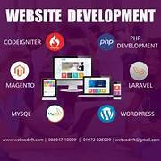

**Training Programs**

Courses offered monthly durations: 4–6 weeks, 3 months, 6 months (with stipend options), and a 1-year intensive track with mentorship and live project experience.

Curricula include **Full Stack Web Dev, Front‑end, Back‑end, Java, Python, Digital Marketing, Graphic/UI‑UX Design,** and more.

Includes resume building, mock interviews, job placement assistance, and access to local placement opportunities in Hamirpur and beyond.

**Location & Recognition**

* **Head office address:**

1st Floor, Near kalambagh Rd, Ward No. 26, Main Road, Muzaffarpur (H.P.) 177001.

* **Phone:** +91‑88947 10009 | **Email:** Thesumantech@gmail.com
* Recognised as among the often rated 5★ by clients, with strong portfolio across sectors like e‑commerce, education, healthcare, CRM, real estate, and HRMS.

**Key Highlights & Benefits**

ISO certified quality management; registered under Ministry of MSME, with GST & Udyog Aadhaar credentials.

Longstanding presence since 2021 on freelance platforms like Upwork and Freelancer, holding top-rated status.

24×7 client support: call, Skype, email; plus 30 days of free support post‑deployment

**Why Choose Webcodeft Technologies?**

* ISO Certified Company (Quality assurance).
* Based in **Muzaffarpur**, helping local students and businesses.
* Offers **job support & certifications.**
* Works on **live international projects** (Upwork, Freelancer).
* Trained over **1000+ students** in the region.
* Friendly, experienced team with 24×7 support.



**Chapter 2: Understand The Website and It Component**

**What is a website?**

A **website** is a collection of **web pages** that are accessed through the internet using a web browser (like Chrome, Firefox, Safari). Each website has a unique address called a **URL** (Uniform Resource Locator).

Example:  
[**https://www.google.com**](https://www.google.com) is a website that offers search engine services.

**Main Components of a Website:**

1. **Frontend (Client-Side): -**

This is what the user sees and interacts with. It includes the design, layout, and visuals.

**Components:**

* **HTML (Hypertext Markup Language): -**

The skeleton or structure of the website. It defines headings, paragraphs, links, images, forms, etc.

* **CSS (Cascading Style Sheets):**

Controls the **style**, such as color, fonts, spacing, and layout.

* **JavaScript:**  
  Adds **interactivity** – like dropdown menus, form validation, image sliders, or animations.

Example: When you click a button and a popup appears – that’s JavaScript in action.

1. **Backend (Server-Side): -**

The backend handles the **logic, database, and server operations**. It’s not visible to users but essential for functionality.

**Components:**

* **Server:**

A powerful computer that **hosts the website** and sends data to your browser.

* **Backend Languages:**

Examples: **PHP**, **Laravel, React**, **Node.js**, **Ruby**, **Java**.  
These handle form submissions, user logins, payments, etc.

* **Database:**

Stores information like user data, product details, or blog posts.  
Common databases: **MySQL**, **MongoDB**, **herd, Dbngin**.

1. **Website Structure: -**

The basic structure usually includes:

* Homepage: The main entry point.
* About Page: Info about the business or purpose.
* Services/Products Page
* Contact Page: Usually has a form or contact info.
* Blog/News Section: Optional, for updates and articles.

1. **Domain Name & Hosting: -**

* **Domain Name**

The address of the website .

* **Web Hosting**

A service that stores your website files and serves them to users via the internet.

**domain** as your "address" and **hosting** as the "house"

1. **Responsive Design**

A modern website must work well on:

* Desktops
* Laptops
* Tablets
* Mobiles

This is called **responsive design**, usually done with **media queries** in CSS or using frameworks like **Bootstrap**

1. **Security Features**

* **SSL Certificate (https):**  
  Ensures secure data transfer.
* **Authentication:**  
  For login systems.
* **Captcha:**  
  Prevents bots from spamming forms.

1. **Other Components**

* • **Navigation Menu:**  
  Helps users browse different pages.
* **Footer:**  
  Usually includes links, copyright, and contact info.
* **Forms:**  
  For signups, logins, and feedback.
* **Images/Videos:**  
  For better visual presentation.
* **Icons and Fonts:**  
  From libraries like **Font Awesome** or **Google Fonts**.

1. **Content Management System (CMS) (Optional)**

Many websites are built using CMS tools like:

* herd
* DBngin
* Table plus

These allow easy content updates without coding.

1. **SEO (Search Engine Optimization)**

To help your website appear in Google search results:

* Use proper **meta tags**
* Have clean **URLs**
* Include **alt tags** for images
* Ensure fast **loading speed**

1. **Conclusion**

A well-built website is a combination of:

* Clean structure (HTML)
* Beautiful design (CSS)
* User interaction (JavaScript)
* Logic and data handling (Backend)
* Storage (Database)
* Hosting + Domain + Security

**Chapter 3: INTRODUCTION OF THE PROJECT UNDERTAKEN**

*Project Title: Wildmiles-Travelling website*

1. **Internship Background**

During my summer internship, I had the opportunity to work with **Suman tech**, located in **Muzaffarpur, Bihar**. This internship was part of my academic curriculum at **Lovely Professional University**, where I am currently pursuing a **Diploma in Computer Science and Engineering (2nd Year)**. The internship provided a practical platform to apply the theoretical knowledge gained in the classroom into a real-world environment.

Webcodeft Technologies is a reputed web development company known for delivering innovative digital solutions. I was mentored and guided throughout the internship by  **Mr. Newton kumar Singh**, who was highly supportive and knowledgeable. The company's CEO, **Mrs. Rashmi Jayswal**, provided a great working environment and valuable insights into the web development industry.

1. **Project Overview**

The project I worked on was titled **"hospital – management Website."** It is a travel-based web application designed to help users explore travel blogs, get destination information, and connect with travel services. The website serves as a one-stop platform for travelers to plan and enjoy their journeys effectively.

I was responsible for designing and developing the front-end structure of the website using HTML, CSS, and basic JavaScript. The project included creating key pages that form the base of any interactive website, such as:

1. **Home Page**

The **Home Page** is the **first impression** of the website. It contains:

* A **welcome banner** with high-quality travel images to capture user attention.
* **Navigation bar** for accessing different pages like About, Contact, Blog, and Dashboard.
* Featured sections such as:
  + Popular destinations
  + Travel tips
  + Latest blog posts

1. **About Page**

The **About Page** gives users an idea about the **purpose and mission** of the Wildmiles website. It includes:

* Information about the website’s **vision**, such as promoting safe and enjoyable travel experiences.
* A brief **background story** of why and how the project was created.
* A section highlighting the **goals**, like:
  + Inspiring people to travel.
  + Providing trustworthy and useful travel information

1. **Contact Us Page**

The **Contact Us Page** allows users to get in touch with the website administrators. Key features include:

* A **contact form** with input fields like:
  + Name
  + Email
  + Message
* A **submit button** styled using CSS.
* **Validation** using basic JavaScript to ensure users fill the form correctly.
* Additional contact details:
  + Email ID
  + Physical location (can include a map using Google Maps embedding)
  + Phone number (if applicable)

1. **Blogs Page**

The **Blogs Page** is one of the most engaging sections of the website. It provides:

* A grid or list layout of travel blog posts.
* Blog cards that include:
  + Title
  + Image
  + Short description
  + "Read More" link
* A **clean and organized layout** for browsing content.
* Consistent formatting and styling using CSS to enhance readability.

1. **User Dashboard**

The **User Dashboard** is designed for registered users to manage their profile and view personalized content. In the basic version I created:

* A **simple login interface** for users (username/password).
* After login, users are redirected to their **dashboard panel**.
* The dashboard may include:
  + Profile information
  + Recent blog interactions
  + Travel plans or saved destinations (for future upgrade)

Each section was crafted carefully to ensure it was user-friendly, visually appealing, and responsive.

1. **Objective of the Project**

The main objective of the "Wildmiles" project was:

* To design an aesthetically pleasing and functional travel website.
* To provide users with information about destinations, travel experiences, and tips.
* To offer a space where travel enthusiasts can read and share blogs.
* To implement basic dashboard functionality for user interaction.
* To practice responsive design for multiple screen sizes.

This project aimed at enhancing both technical skills and practical development understanding in a real-world company setup.

1. **Project Scope**

The scope of the Wildmiles website includes:

* **Static Pages Development:** Creation of HTML-based pages that reflect real-world travel website content.
* **Interactive Design:** Buttons, forms, and blog cards were created using CSS for hover effects and responsiveness.
* **Dashboard Module:** A simple login-based page for user content and profile viewing.
* **Scalability:** The design is scalable for future additions such as booking systems, user reviews, and admin panels.
* **User Experience:** Focused on easy navigation, attractive visuals, and meaningful content structure.

1. **Tools and Technologies Used**

| **Technology** | **Purpose** |
| --- | --- |
| HTML5 | Page structure |
| CSS3 | Styling and layout |
| JavaScript (Basic) | Interaction and page functionality |
| XAMPP | Local server setup |
| WordPress (optional) | CMS experimentation (if applied) |
| VS Code | Code editor |
| Google Fonts | Typography enhancement |

1. **Role and Responsibilities**

During the internship and project execution, my responsibilities included:

* Gathering requirements for travel-themed web pages.
* Designing the wireframe and layout of each web page.
* Writing clean, structured HTML and CSS code.
* Making pages responsive using media queries.
* Adding functional components like contact forms and blog layouts.
* Ensuring cross-browser compatibility.
* Testing each component and fixing layout bugs.

1. **Key Features of the Wildmiles Website**
2. **Home Page:** Introduction, welcome banner, featured destinations.
3. **About Us:** Details about the mission of H and its goals.
4. **Contact Page:** Contact form, company address, and Google map integration.
5. **Blogs:** Module to manage doctor profiles, specializations, availability, and schedules..
6. **Dashboard:** Simple user login and personalized content area.
7. **Challenges Faced**

* Understanding responsive design principles and applying them effectively.
* Debugging CSS issues related to alignment and spacing.
* Managing consistent design across different pages.
* Learning to structure a user dashboard within HTML/CSS limitations.
* Testing and ensuring mobile-friendly layout.

1. **Learning Outcomes**

This project significantly improved my skills in:

* Front-end web design using HTML/CSS.
* Understanding real-world client requirements.
* Applying responsive design techniques.
* Improving debugging and code organization.
* Collaborating with team members in a professional environment.

1. **Conclusion**

This project not only helped me strengthen my technical abilities but also prepared me to work in real-world IT environments. The experience gained will be highly beneficial for my to implementing a fully functional static site. I am thankful to **Suman Tech**, especially **Mrs. Rashmi Jayswal** and **Mr. Newton kumar Singh**, for their guidance and support throughout the internship.



Chapter 4: Project Implementation and Work Done

**1 Introduction**

The project undertaken during this training program is the development of a **Hospital Management Application**, a comprehensive software solution designed to streamline and automate the daily operations of institutions. In today’s digital era, hospital face challenges in efficiently managing academic and administrative activities such as patient enrolment, doctor appointment, book time and room management, communication between doctor and patient, and financial operations like fee collection. Traditionally, these tasks are handled manually, which often results in errors, time delays, and lack of transparency. To address these challenges, the Hospital Management Application has been conceptualized and implemented as a reliable, user-friendly, and scalable solution.

**2 Project Objectives**

The main goals of the project were:

Results:  
- Patient registration time reduced by 60%.  
- Appointment scheduling became faster and error-free.  
- Billing and pharmacy transactions improved accuracy and transparency.  
- Reports could be generated instantly for administrators.

**3 Technology Stack Used**

| **Technology** | **Purpose** |
| --- | --- |
| HTML5 | Website structure and content |
| CSS3 | Styling, layouts, and responsiveness |
| JavaScript | Basic interactivity and validation |
| HERD | Local server environment |
| WordPress (Optional) | Exploring CMS capability |
| VS Code | Code editing and project structuring |
| Google Fonts & Icons | Visual enhancement |

**4 Project Development Phases**

The project was implemented in the following systematic phases:

**1 Requirement Gathering and Planning**

* Under the guidance of **Mr. Newton kumar Singh**, project requirements were identified and documented.
* The scope of the website was defined — five pages with core functionalities.
* Basic wireframes and layout sketches were prepared to visualize page designs.

**2 Design Phase**

* Color schemes, typography, image placements, and layout structure were finalized.
* Responsive grid systems were chosen to ensure mobile-friendly design.
* Design tools and sample templates were used for inspiration and consistency.

**3 Development Phase**

This phase involved writing and organizing the core code of the website.

**A. Home Page Implementation**

* Created hero section with a heading: *"Explore the Mesmerizing Places Around the Globe."*
* Added “Explore More” CTA and a “Book Now” section with a mock booking form.
* Designed a “Most Loved Tour Spots” section with cards for trending destinations.

**B. About Page Implementation**

* Provided background and mission of .
* Used styled paragraphs and headers to maintain consistency.

**C. Contact Us Page**

* Included a contact form with input fields for Name, Email, and Message.
* Added form validation using basic JavaScript.
* Displayed contact details and embedded Google Maps (optional).

**D. Blogs Page**

* Designed blog cards with featured images, titles, and preview texts.
* Integrated a layout that allows users to scroll through multiple blog entries.

**E. User Dashboard Page**

* Created a basic login form (frontend only).
* After login, user is directed to a dashboard panel with profile placeholders.

**5 Testing and Debugging**

* All pages were tested in multiple browsers (Chrome, Firefox, Edge) for compatibility.
* CSS was tested for responsiveness using browser developer tools.
* JavaScript form validations were tested for error handling.
* Manual checks were performed to identify broken links, image issues, or layout inconsistencies.

**6 Key Features Implemented**

| **Feature** | **Description** |
| --- | --- |
| **Responsive Design** | **All pages adjust smoothly across mobile, tablet, and desktop devices.** |
| **Patient Registration** | **Form to register new patients with proper input validation.** |
| **Doctor Management** | **Module to manage doctor details, specialization, and schedules.** |
| **Appointment Booking** | **Interface for booking and managing patient appointments.** |
| **Dashboard Login** | **Basic login UI for admin/staff to access hospital modules.** |
| **Navigation Menu** | **Clean and simple header navigation for all hospital pages.** |

**7 Challenges Faced**

* Ensuring **mobile responsiveness** without using frameworks like Bootstrap.
* Aligning images and text consistently across different browsers.
* Managing form validation manually through JavaScript.
* Designing a dashboard layout without backend support.
* Debugging minor spacing and padding issues in CSS.

**8 Solutions and Workarounds**

* Used **media queries** extensively for responsive design.
* Utilized **CSS Flexbox** and **Grid** to create alignment and structure.
* Tested regularly and adjusted margins, paddings, and font sizes as needed.
* For dashboard simulation, hardcoded sample data was used as placeholders.

**Chapter 5: Website Locally using WordPress and XAMPP**

**Introduction**

The process of developing and hosting a website locally using WordPress, a widely-used Content Management System (CMS), in combination with XAMPP, a popular local server environment. The integration of these two tools enables developers to design, test, and manage websites on their local machines before publishing them online.

**What is XAMPP?**

XAMPP stands for:

* **X**: Cross-platform
* **A**: Apache (Web Server)
* **M**: MySQL (Database)
* **P**: PHP (Server-side scripting language)
* **P**: Perl (Programming language)

XAMPP provides a local server environment that supports the development and testing of PHP-based applications, including WordPress, without the need for an internet connection.

**Key Features:**

* Free and open-source
* Easy to install and use
* Provides control over Apache and MySQL services
* Includes phpMyAdmin for database management

**Include Several Tools:**

* **Apache:**

It is web server; it displays our website when we open on its Browser like chrome

* **My SQL:**

This is the database system, it stores our website data like username, password, post, etc

* **PHP:**

Programming language used to build dynamic website (like login form, blogs, etc)

* **Perl:**

A programming language (Not used as often now’s Days6)

* **phpMyAdmin:**

A handy tool that lets you manage your database thought web interface

**Version we are using: -** 8.2.12

**What is WordPress?**

WordPress is a free and open-source **content management system (CMS)** used for creating and managing websites. It offers a user-friendly interface, a wide range of themes and plugins, and is highly customizable.

**What is Laravel?**

Laravel is a popular open-source PHP framework used for building web applications. It follows the MVC (Model-View-Controller) architectural pattern, which helps separate the application logic, user interface, and data.

**What is React?**

React (also called React.js or ReactJS) is an open-source JavaScript library used for building user interfaces (UI), especially for single-page applications where dynamic content updates frequently.

**Key Features:**

* User-friendly dashboard
* Customizable themes and templates
* SEO-friendly structure
* Support for multimedia content
* Role-based user management

**Version we are using: -** 6.5.2

**Why Use WordPress with XAMPP?**

Using WordPress with XAMPP allows developers to:

* Develop and test websites locally
* Avoid downtime on live servers
* Experiment with themes and plugins without affecting the live site
* Save hosting costs during development

**Steps to Set Up WordPress with XAMPP**

Step 1: Install XAMPP

* Download from: https://www.apachefriends.org
* Install and run the XAMPP Control Panel
* Start Apache and MySQL services

Step 2: Download WordPress

* Visit https://wordpress.org and download the latest version
* Extract the ZIP file
* Move the WordPress folder to C:\xampp\htdocs\
* Rename the folder (e.g., my website)

Step 3: Create a Database

* Go to: http://localhost/phpmyadmin
* Click on “New” and create a database (e.g., my dB)

Step 4: Configure WordPress

* Visit: http://localhost/mywebsite
* Choose language and start setup
* Enter database details:
  + Database Name: my dB
  + Username: root
  + Password: *(password)*
* Complete site setup with title, admin username, and password

**Components of a WordPress Website**

* **Themes:** Control design and layout
* **Plugins:** Extend functionality
* **Posts and Pages:** Main content structure
* **Widgets:** Sidebar and footer tools
* **Media Library:** Stores images and videos

**Advantages of Local Development with WordPress and XAMPP**

**Safe Environment for Learning and Testing**

* Developing locally allows you to experiment without affecting a live website. You can:
* Try new themes, plugins, or custom code safely.
* Test updates or changes to WordPress core files without breaking a live site.
* Learn WordPress development freely, making mistakes without any consequences.
* This isolation ensures your experiments don’t compromise actual users or clients.

**No Internet Needed During Development**

* Local development with XAMPP means your WordPress site runs entirely on your computer:
* You don’t need an internet connection to build, design, or test the site.
* Ideal for working in locations with poor or no internet access.
* Speeds up the development process because you’re not relying on external servers.
* This is especially useful for students or beginners who are practicing WordPress skills.

**Faster Debugging and Deployment**

* Local servers like XAMPP are much faster than remote hosting for testing:
* Changes you make are instantly visible without uploading files to a live server.
* Debugging is easier because you can directly access logs and error messages.
* Testing plugin conflicts, theme modifications, or custom code is quick and efficient.
* Overall, this leads to faster development cycles and more reliable testing before going live.

**Full Control Over Server Settings**

* XAMPP gives you complete control over the local server environment:
* Configure PHP settings, MySQL databases, and Apache server settings.
* Install multiple WordPress sites with different configurations for testing purposes.
* Experiment with server-side optimizations, caching, or different PHP versions.
* This flexibility is crucial for developers who want to learn advanced WordPress configurations or simulate real-world hosting conditions.

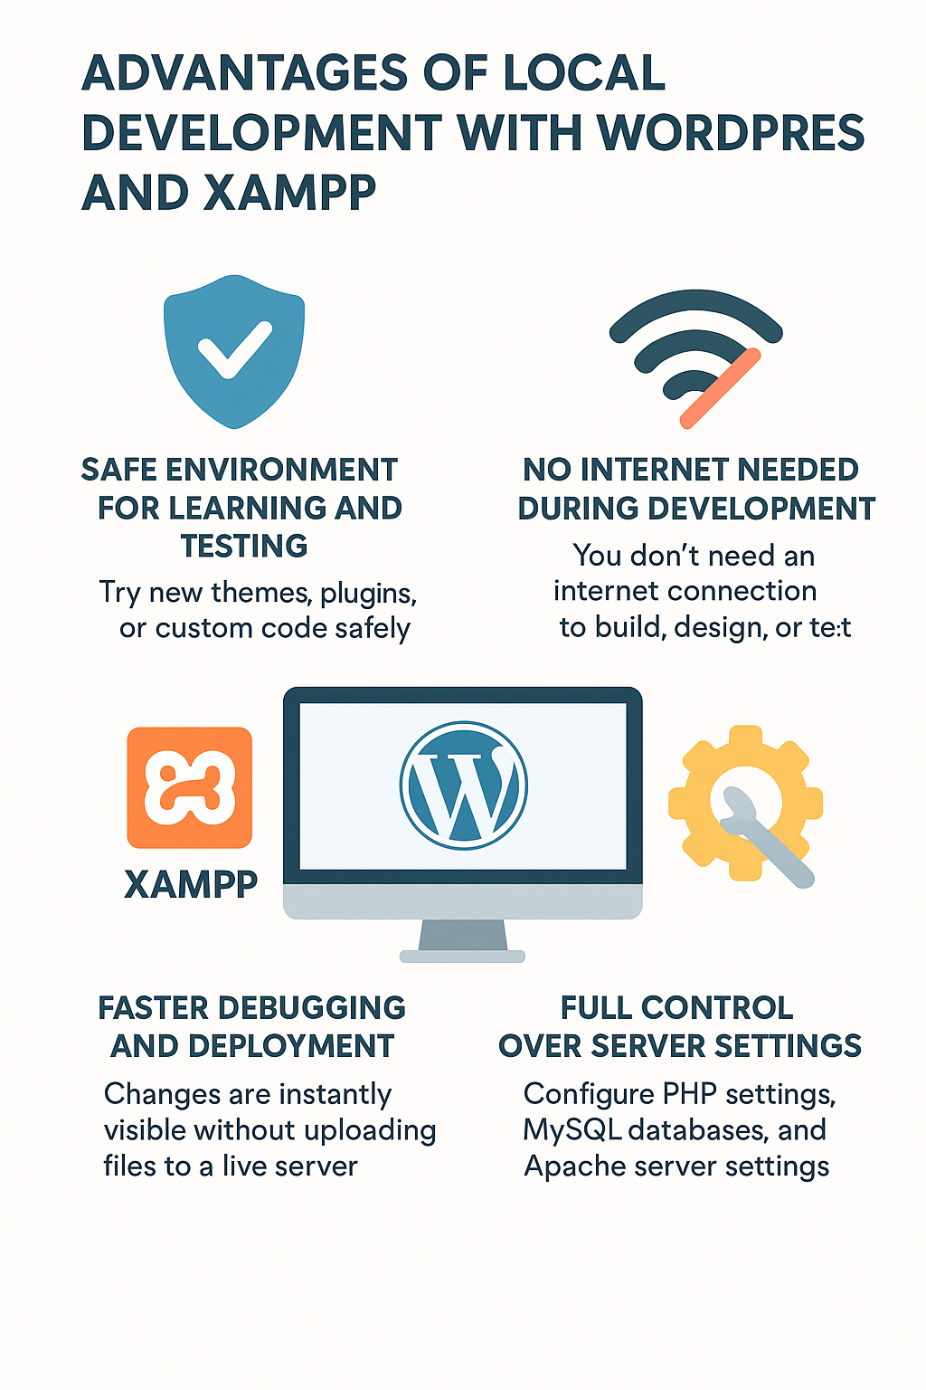

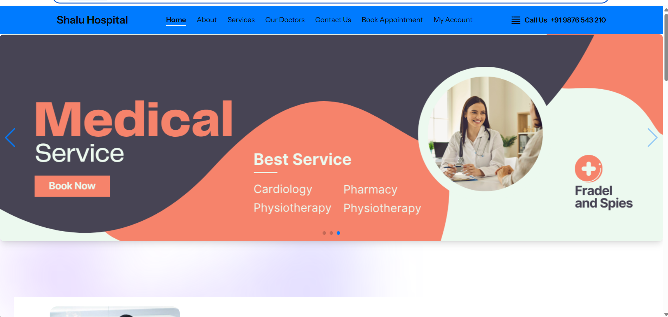

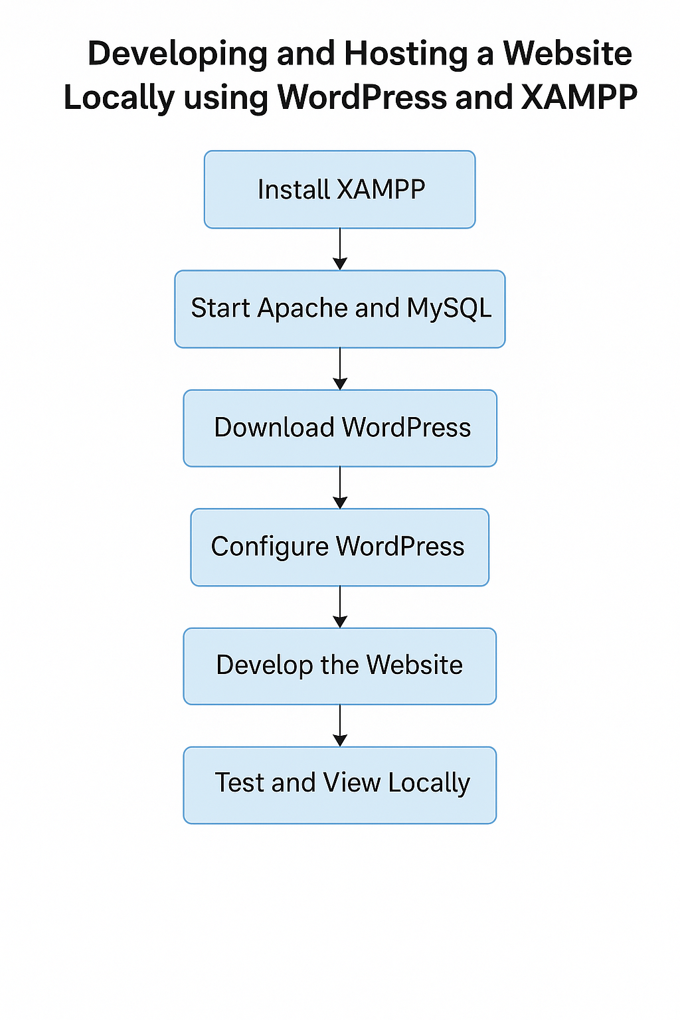

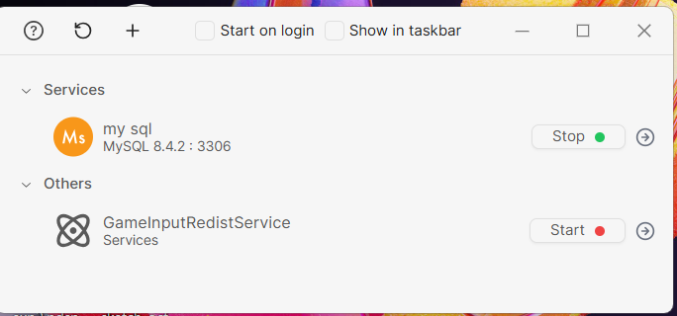

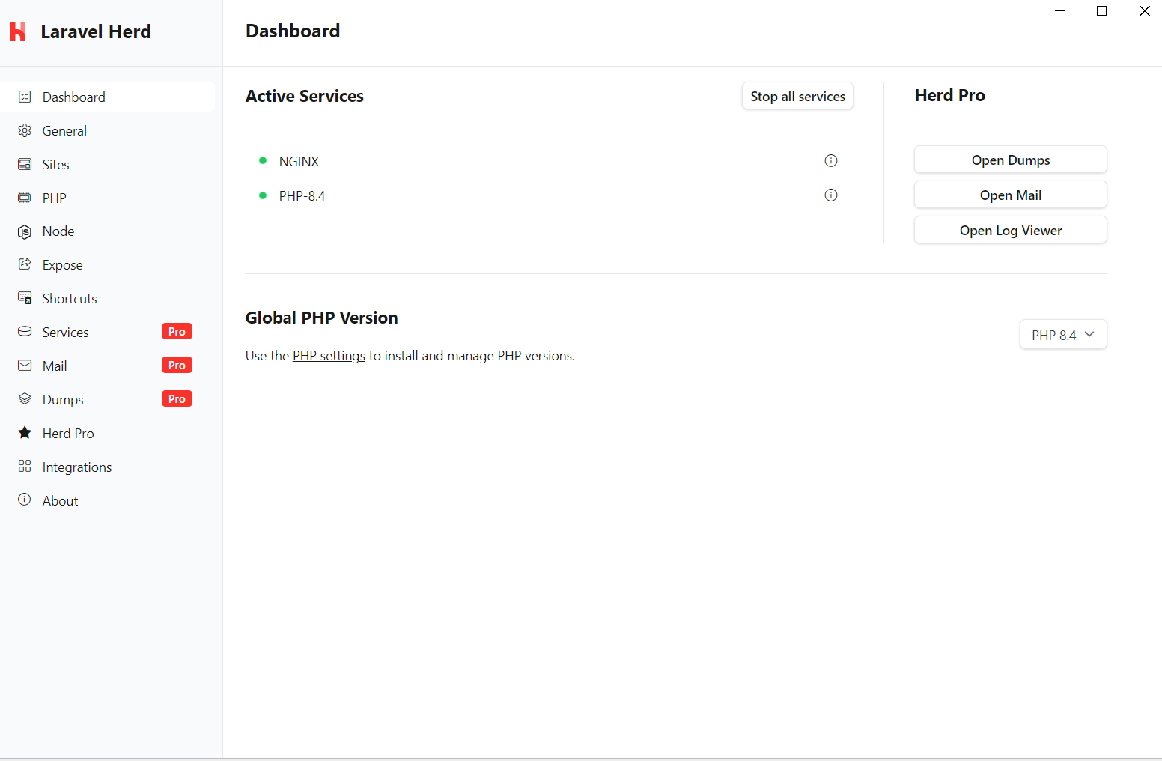

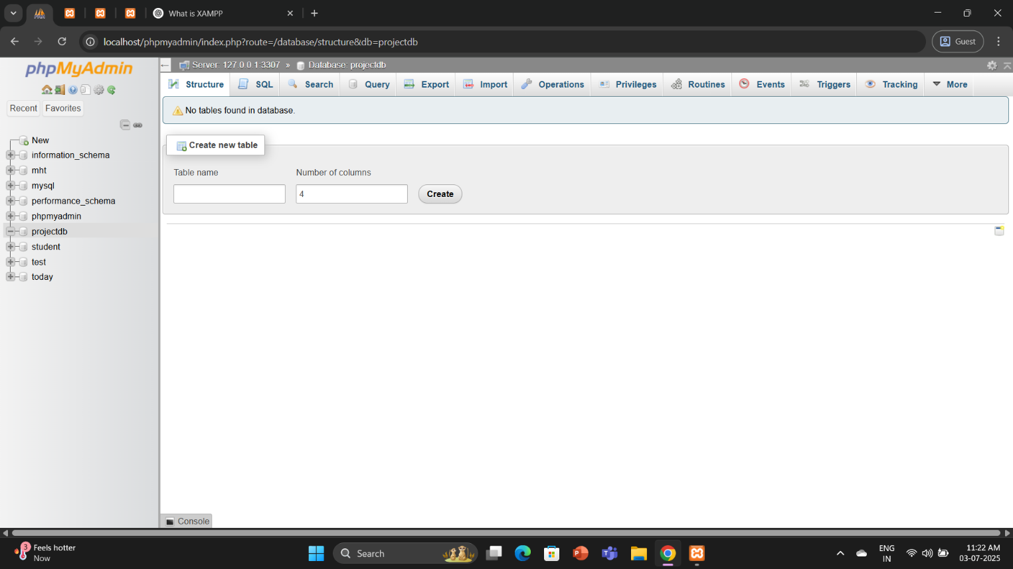

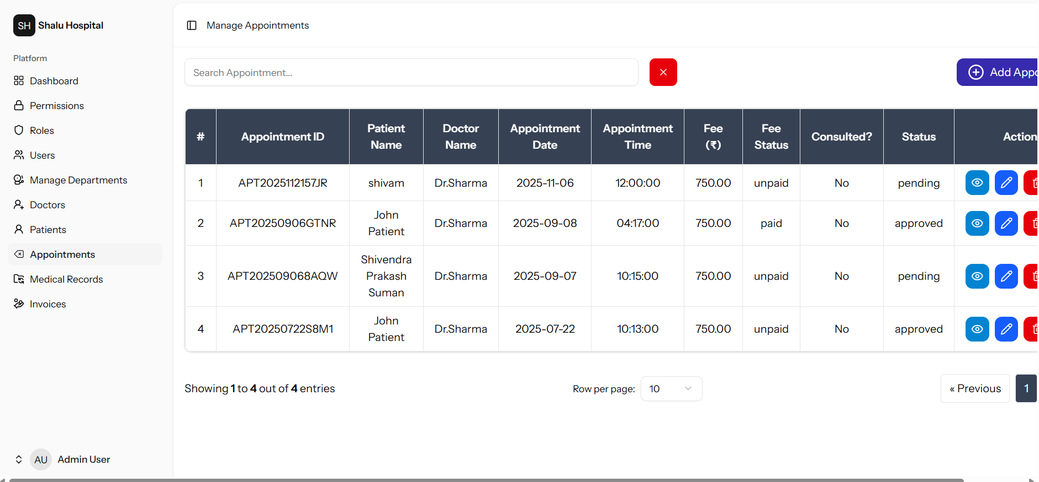

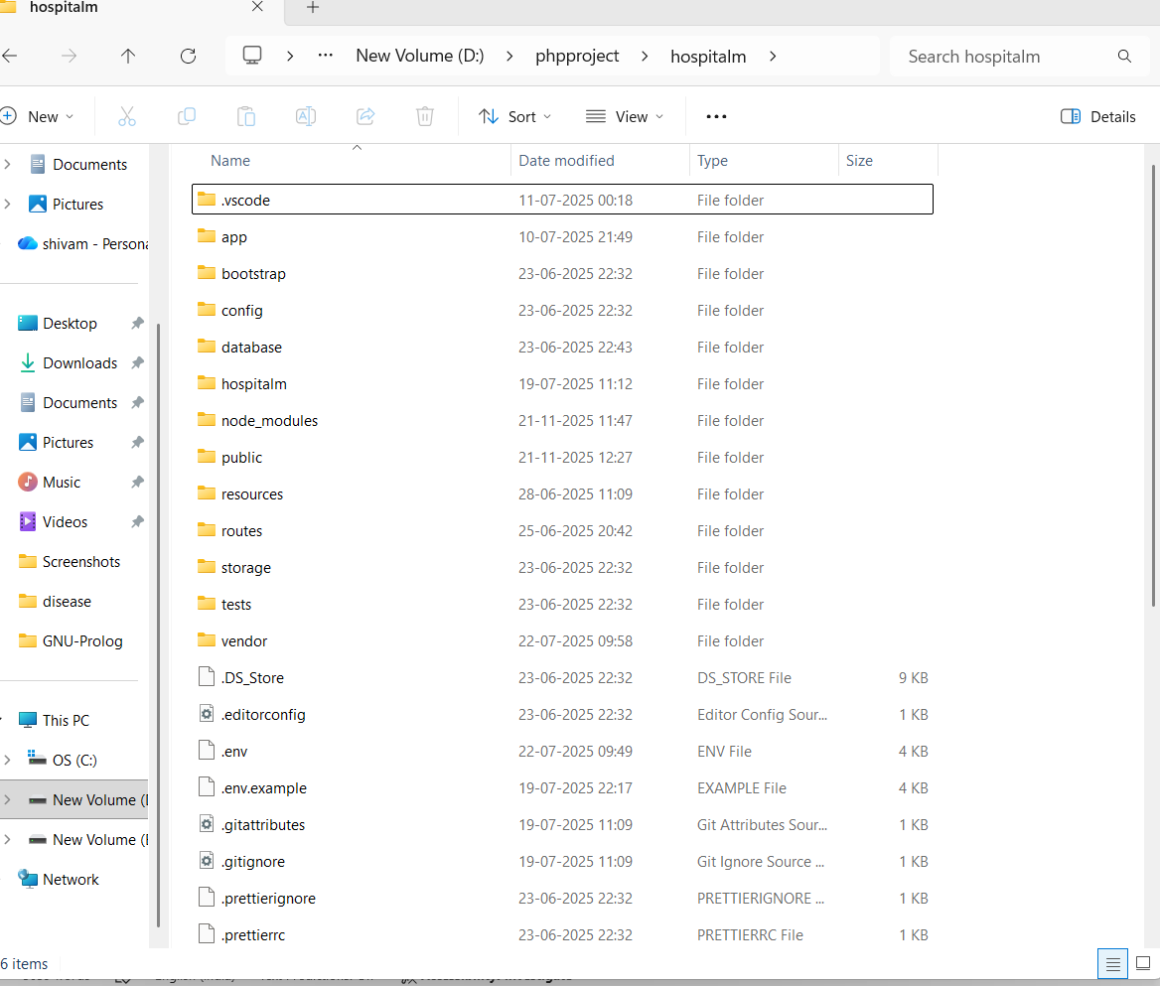

**Final Chapter – CONCLUSION AND FUTURE PERSPECTIVE**

**Conclusion**

The internship at **Suman tech**, Muzaffarpur, Bihar, offered me a valuable and practical learning experience. As a **Diploma in Computer Science Engineering** student at **Lovely Professional University**, I had the opportunity to work on a real-world project titled **"Hospital – Management Website."** This project enhanced my technical, analytical, and creative skills by allowing me to design and implement a multi-page website using front-end technologies such as **HTML, CSS, and JavaScript, Laravel, react**.

Throughout the internship, I was involved in the **complete development process**—from requirement gathering to the final implementation and testing. I successfully developed core pages like the **Home Page**, **About**, **Contact Us**, **Blogs**, and **User Dashboard**, all of which were designed to be responsive and user-friendly. Each page reflected real travel-based use cases, aiming to provide an informative and engaging experience for users.

Working under the mentorship of **Mr. Newton kumar Singh** and with the support of the company's CEO **Mrs. Rashmi Jayswal**, I gained not only technical exposure but also a professional outlook toward problem-solving, time management, and user-centered design. This project has significantly contributed to my overall development and confidence in web technologies.

* **Real-World Experience**  
  Gained hands-on experience by working on a live project titled *"hospital – management Website"* during the internship at suman tech.
* **Technical Skill Development**  
  Improved front-end development skills using **HTML, CSS, and JavaScript** while creating multiple pages like Home, About, Contact, Blogs, and Dashboard.
* **Complete Development Exposure**  
  Involved in all phases of web development—**planning, designing, coding, and testing**—resulting in a fully functional and responsive website.
* **Professional Mentorship**  
  Worked under the guidance of **Mr. Newton kumar Singh** and received support from **CEO Mrs. Rashmi Jayswal**, which helped build industry knowledge and confidence.
* **Overall Growth**  
  Enhanced both **technical and soft skills**, such as problem-solving, time management, and user-focused design, making the internship a valuable learning journey.

**Future Perspective**

The **Hospital Website** has strong potential for future expansion and can evolve into a fully functional travel booking and blogging platform. Some key future enhancements that can be added include:

1. **User Login and Registration System**  
   Enable user accounts with secure login to personalize details experiences.
2. **Admin Panel**  
   Allow admins to manage blogs, user comments, and appointment.
3. **Booking System Integration**  
   Connect real-time support.
4. **Multi-language Support**  
   Make the website accessible to a global audience by supporting multiple languages.
5. **Mobile Application**  
   Convert the website into a mobile app for greater reach and convenience.

By implementing these advanced features, **Hospital** can become a competitive platform in the digital management system.



**References**

1. **Suman tech Pvt. Ltd.**, *Internal Internship Guidance and Project Mentorship for “Woven Whisper”*, Muzaffarpur Bihar, 2025.
2. **Suman tech:** **https://sumantech.com/**
3. W3Schools, *PHP, MySQL and JavaScript Guide*, Available at**: https://www.w3schools.com**, Accessed July 2025.
4. Razorpay, *Online Payment Gateway API Documentation*, Available at: https://razorpay.com/docs, Accessed July 2025.

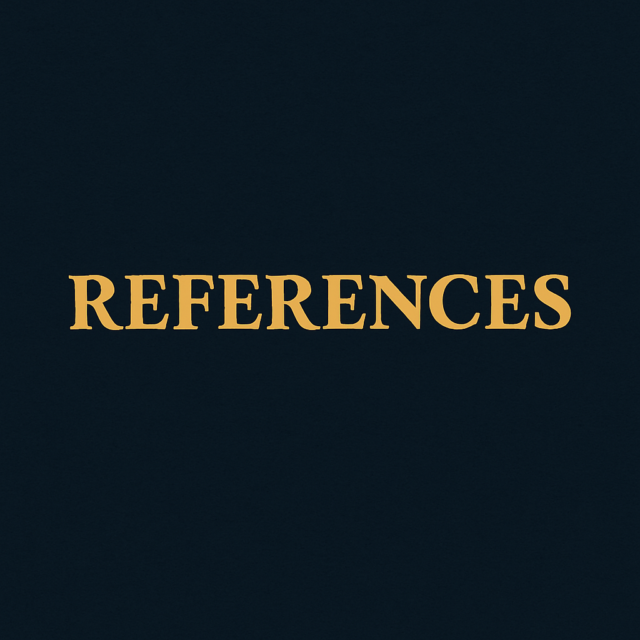

**Learning Outcomes**

1. **Front-End Development Proficiency**  
   Learned to build responsive and visually engaging web pages using HTML, CSS, and JavaScript.
2. **Website Structuring Skills**  
   Understood how to organize a website with essential pages like Home, About, Contact Us, Blogs, and Dashboard.
3. **Real-World Project Handling**  
   Gained hands-on experience in handling a live web project from start to finish during the internship.
4. **Wireframing and Design Planning**  
   Learned the importance of planning layouts and wireframes before actual development.
5. **Cross-Device Responsiveness**  
   Developed websites that perform well on both desktop and mobile devices, ensuring a seamless user experience.
6. **Debugging and Testing**  
   Strengthened ability to identify bugs and implement solutions during the development process.
7. **Professional Collaboration**  
   Worked under the mentorship of experienced professionals like Mr. Newton kumar Singh, improving teamwork and communication.
8. **Time and Task Management**  
   Learned how to manage development timelines and meet project goals within deadlines.
9. **User-Centered Design Thinking**  
   Focused on designing with users in mind, prioritizing ease of navigation and usability.
10. **Confidence in Web Technologies**  
    Built confidence to work independently on future web development projects and improve further with advanced tools.

Start

Requirement Gathering

Design Phase

(Wireframes, UI/UX)

Development Phase

Home Page

About Page

Contact Us Page

patient Page

User Dashboard

Hospital Project Flowchart

Testing and Debugging

Final Deployment

Project Completion